NAME : SHYAM PRASAD V ATRI USC ID : 7708538799 SC1- CE541 A used MATLAB 7.10.0 R2010a

Problem 1

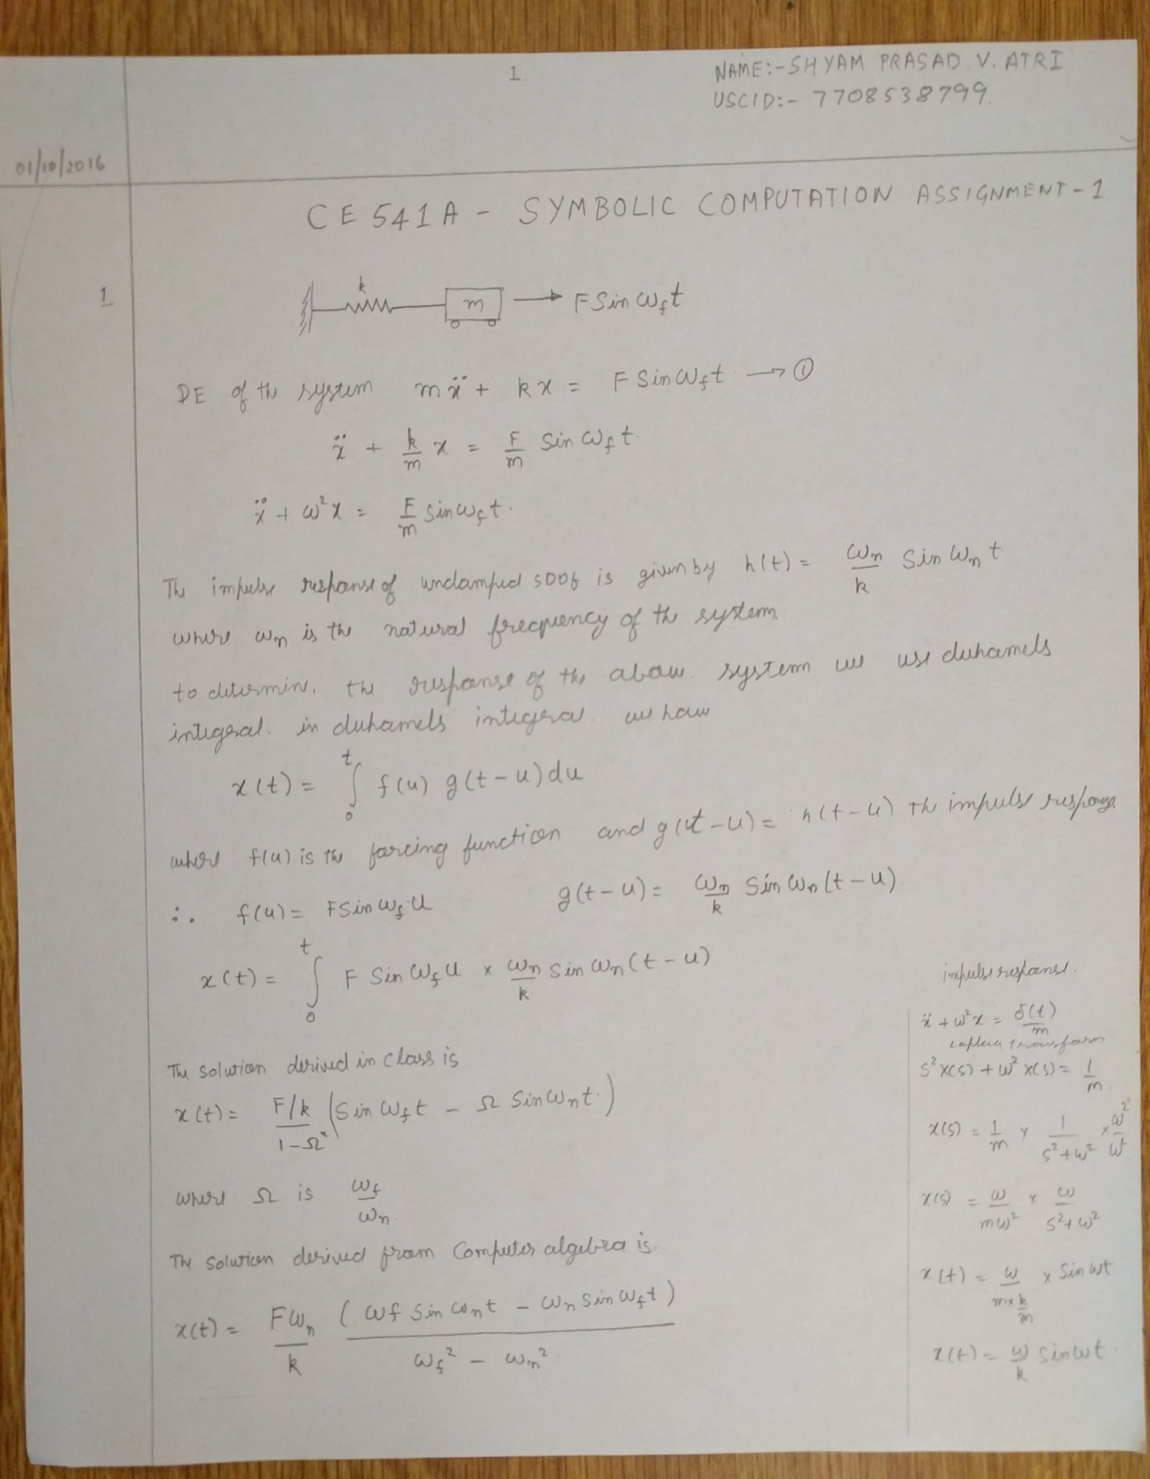

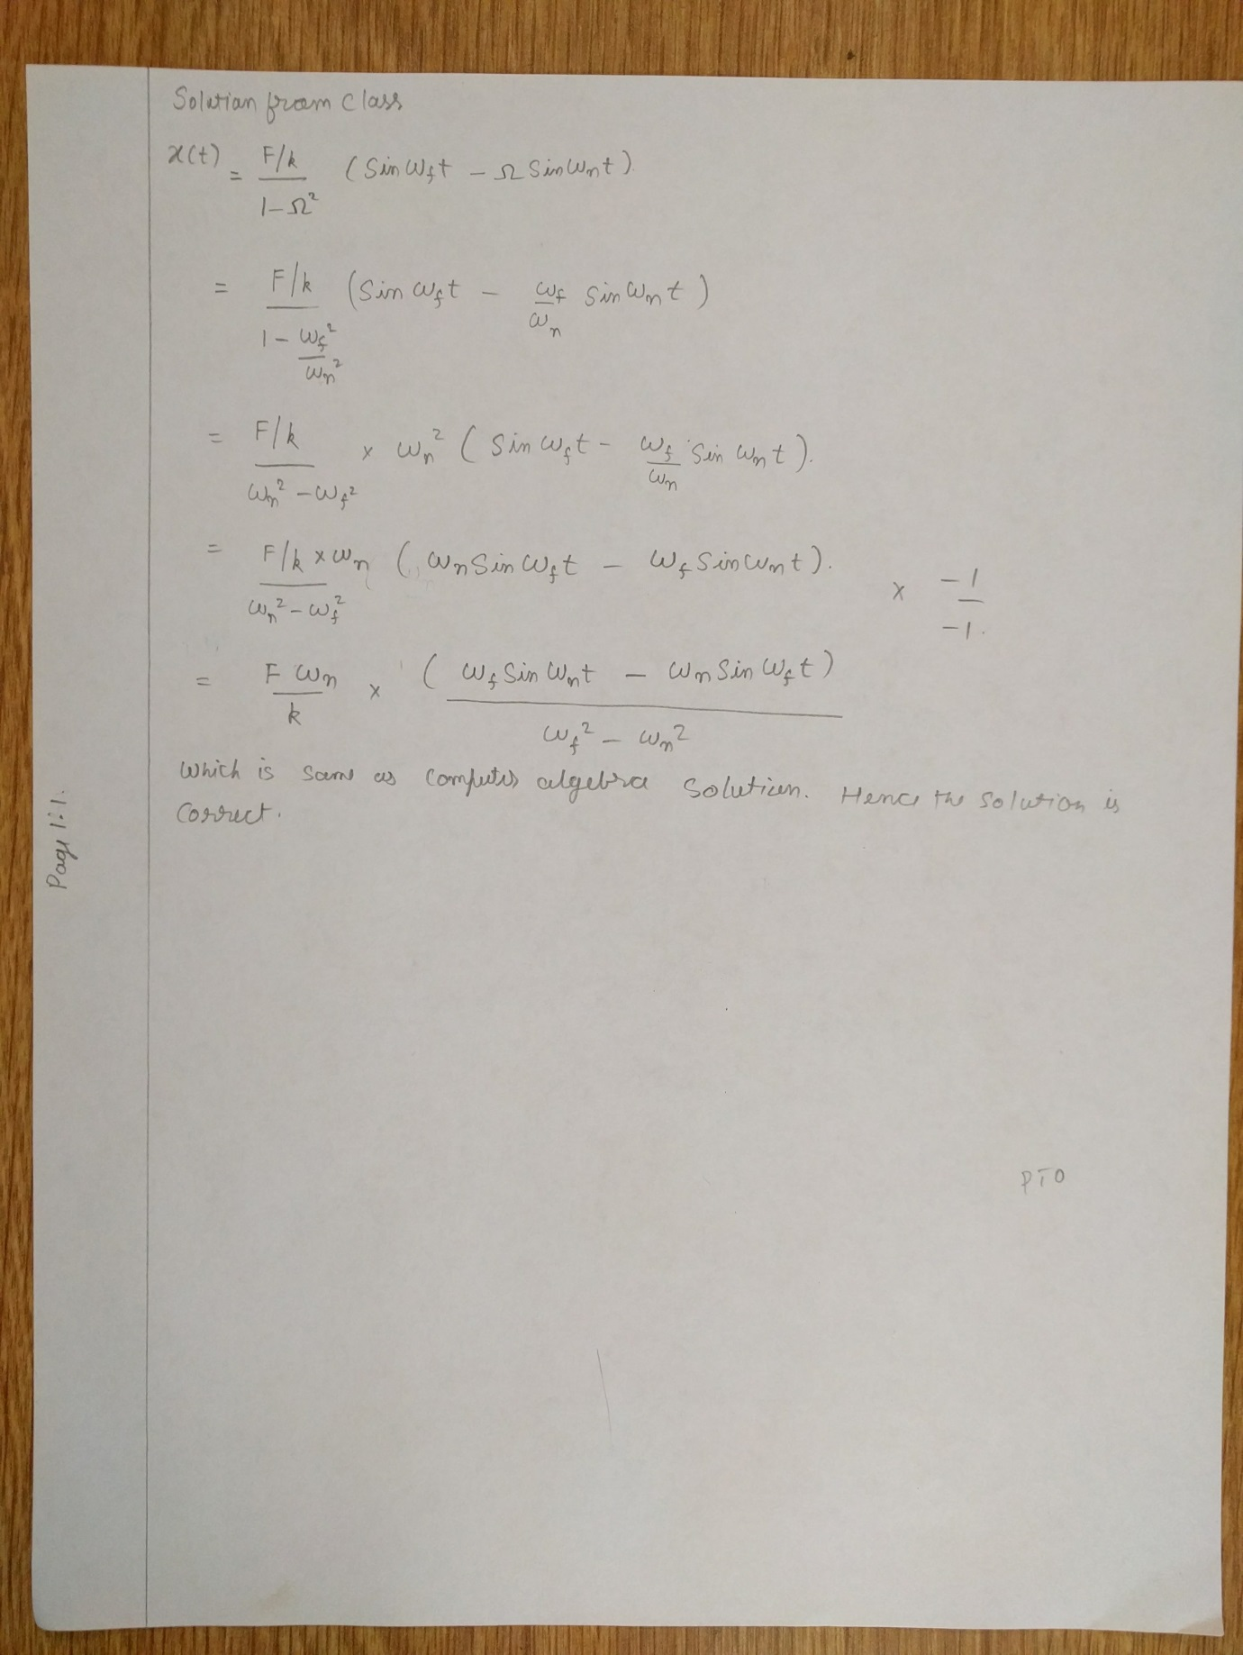

Symbolic Solution

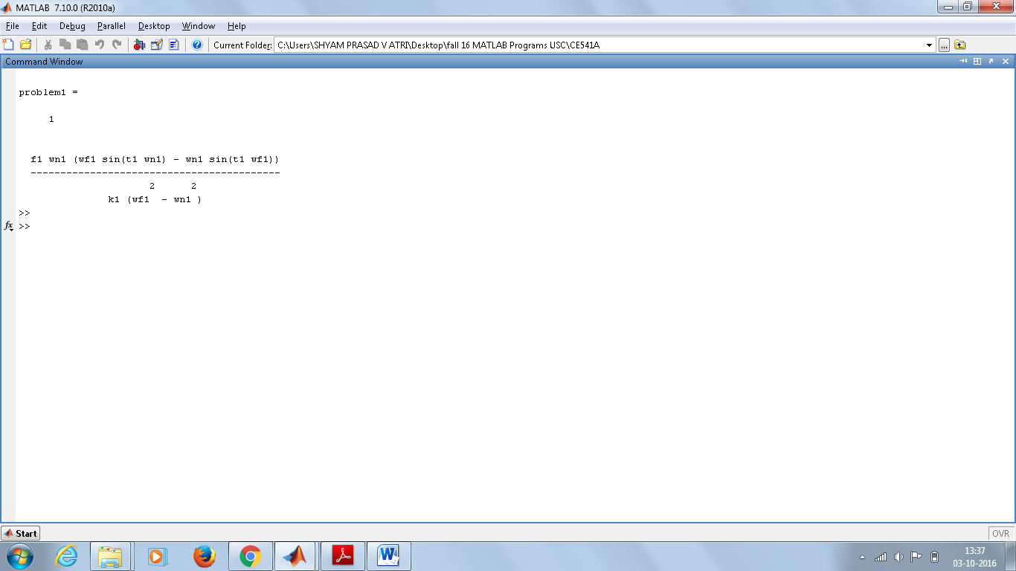

Problem 2A

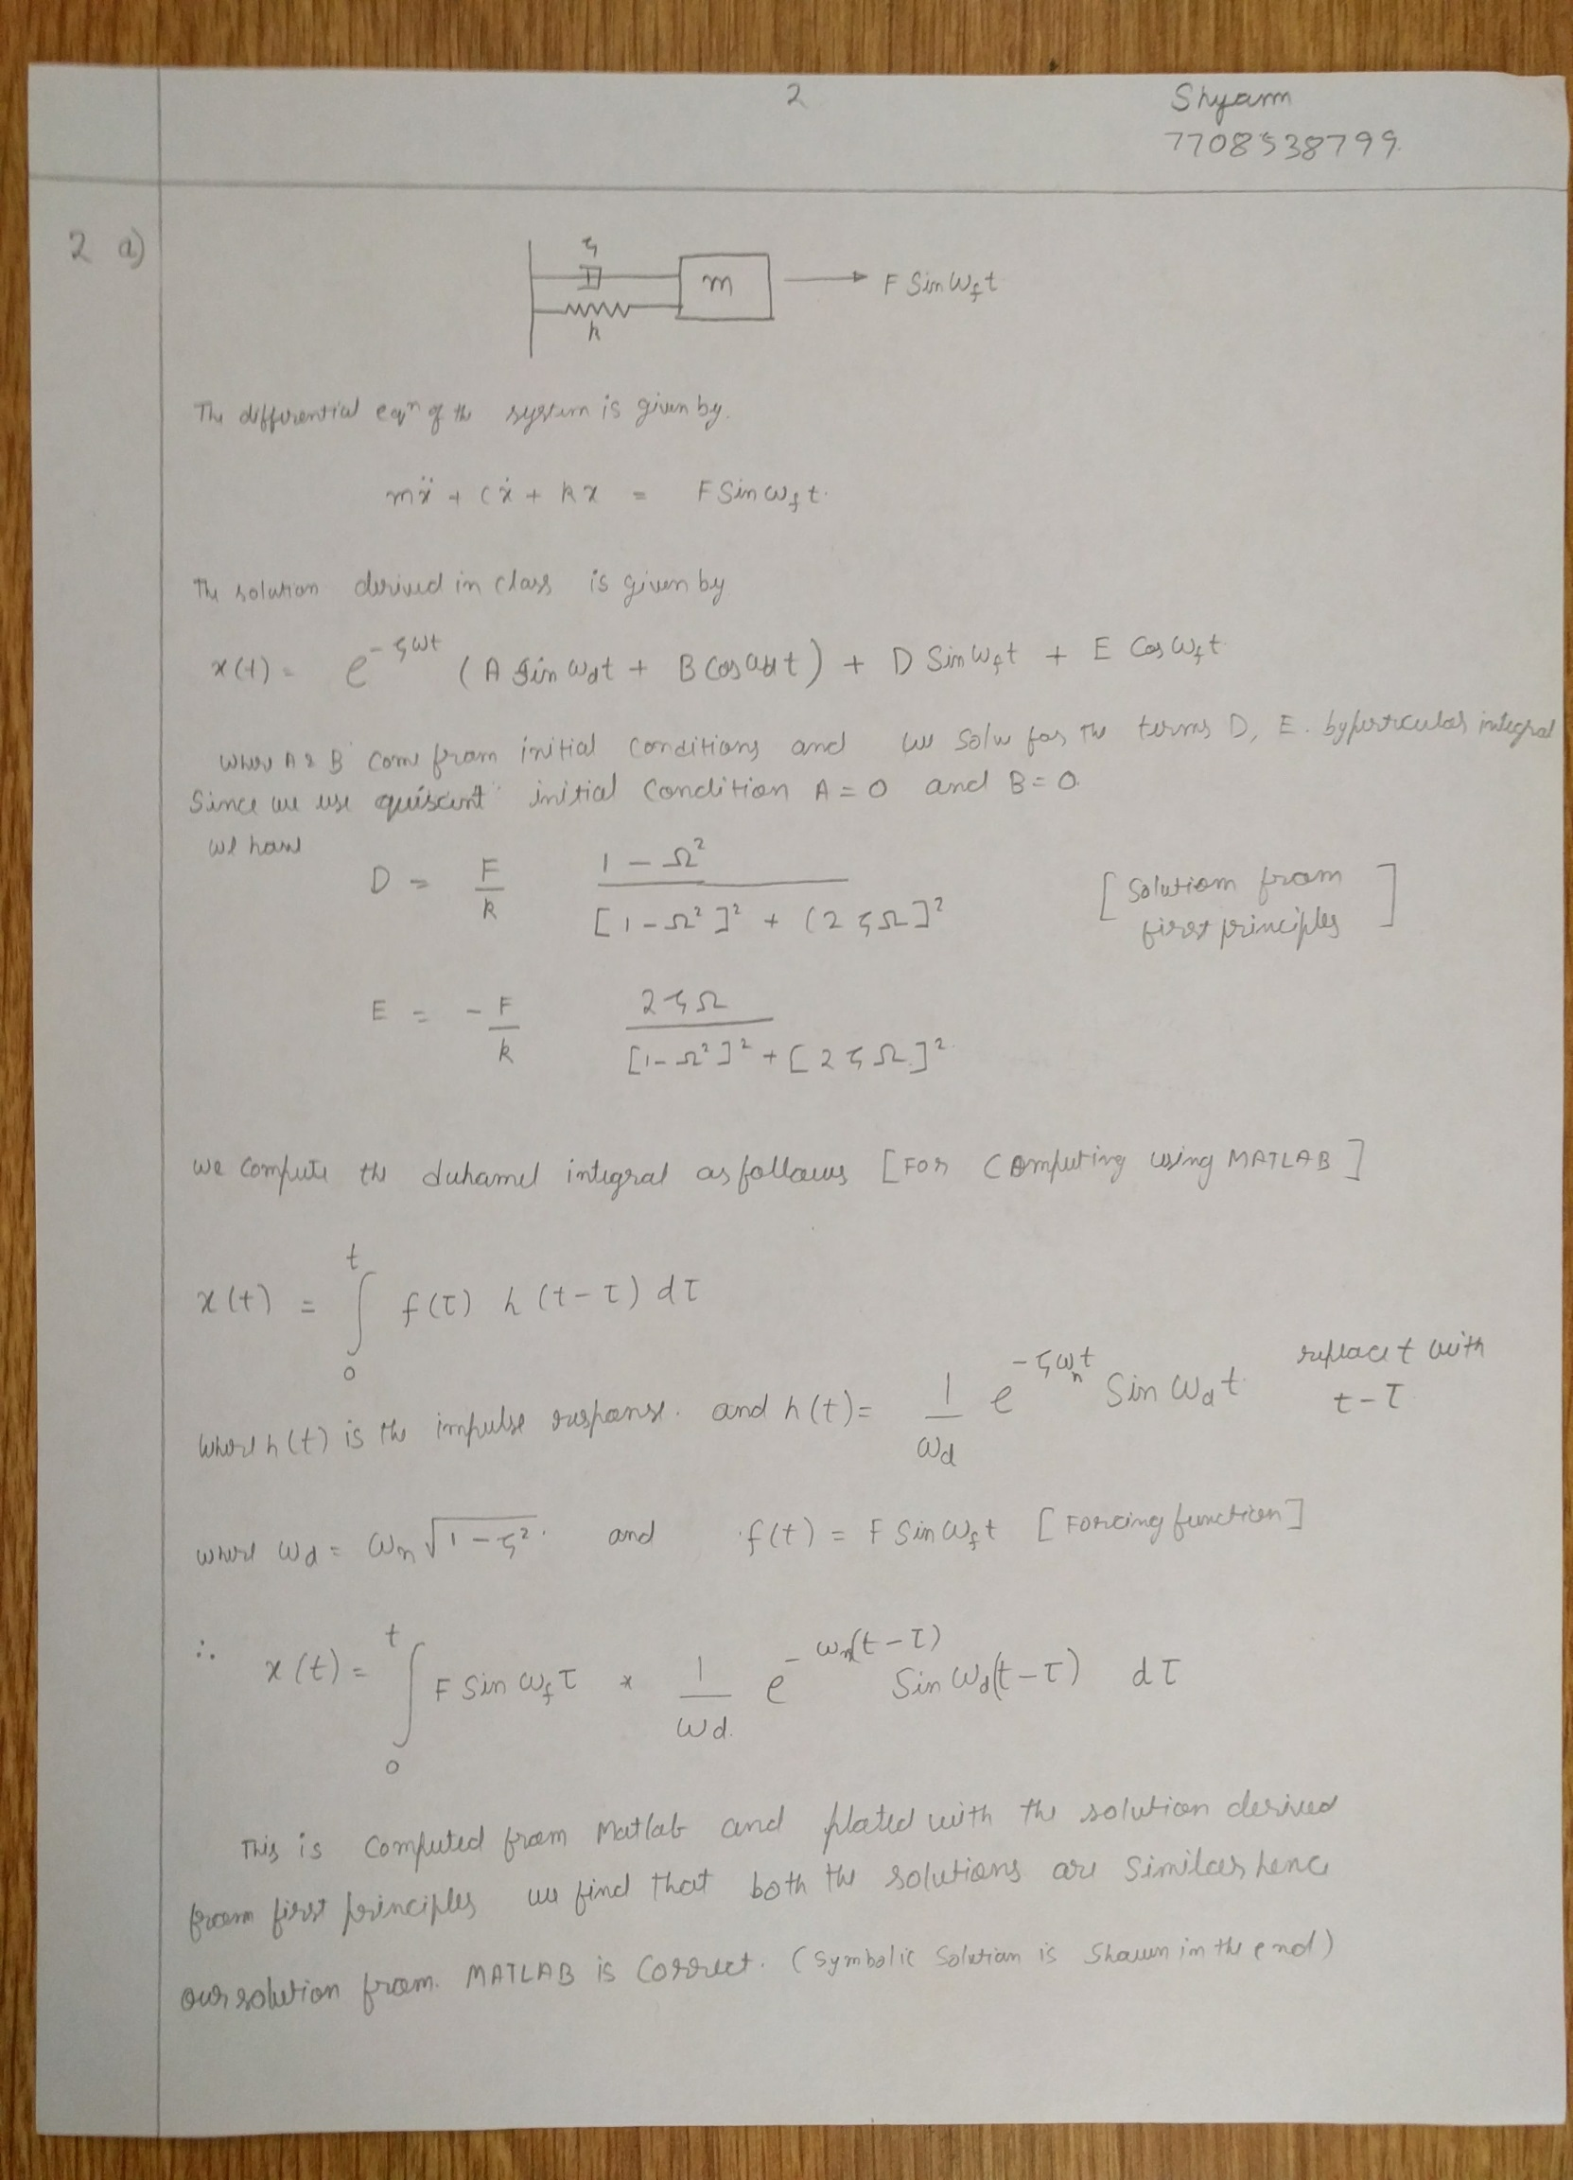

Symbolic Solution

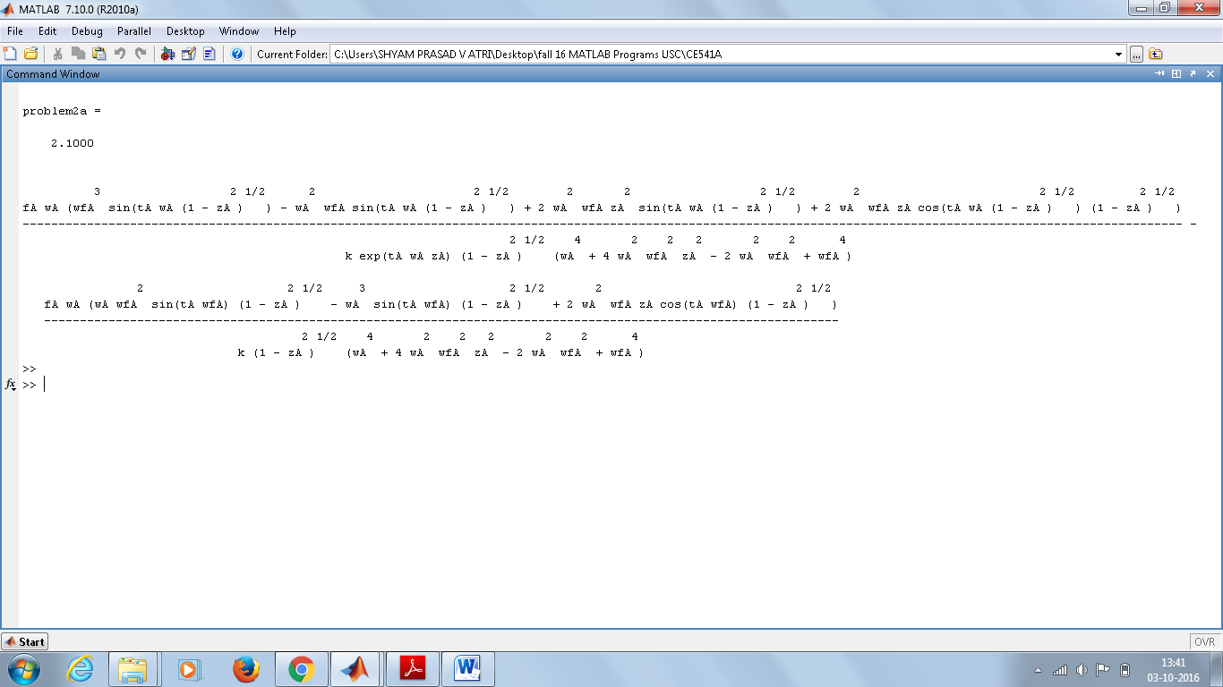

For Plot on LHS:- Plot using Duhamel integral.

For Plot on RHS:- Plot using solution derived in class.

We observe that the transient part dies out as the system reaches steady state.

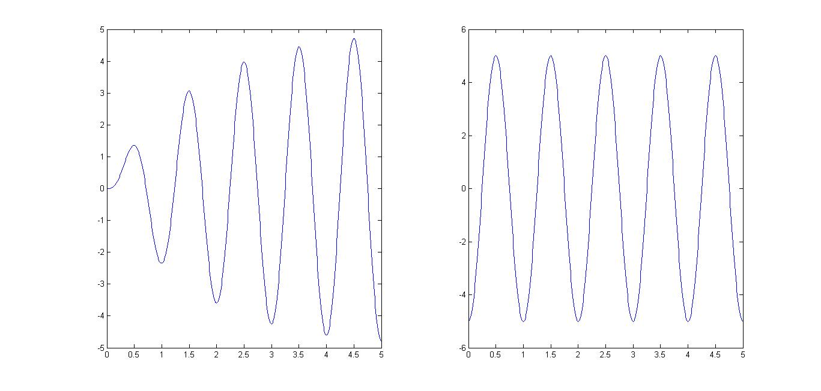

Problem 2b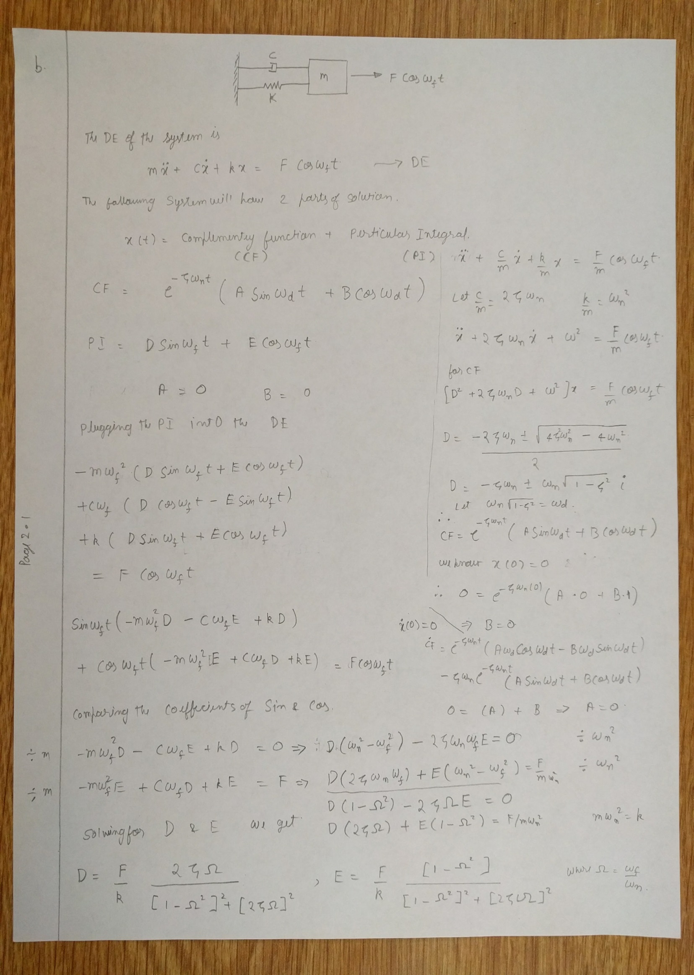

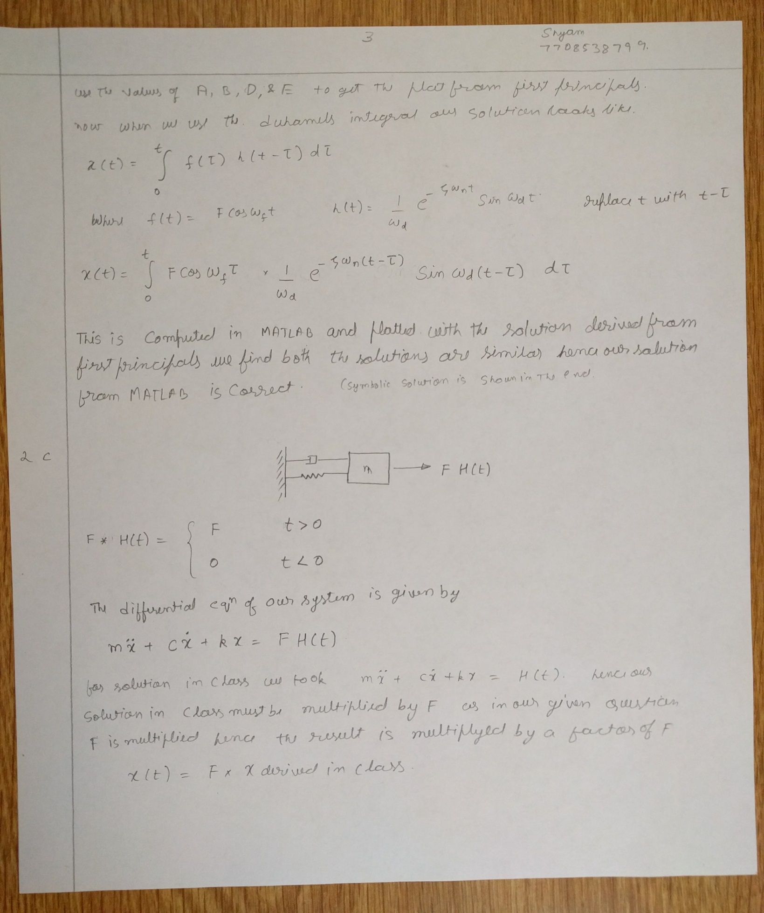

Symbolic Solution

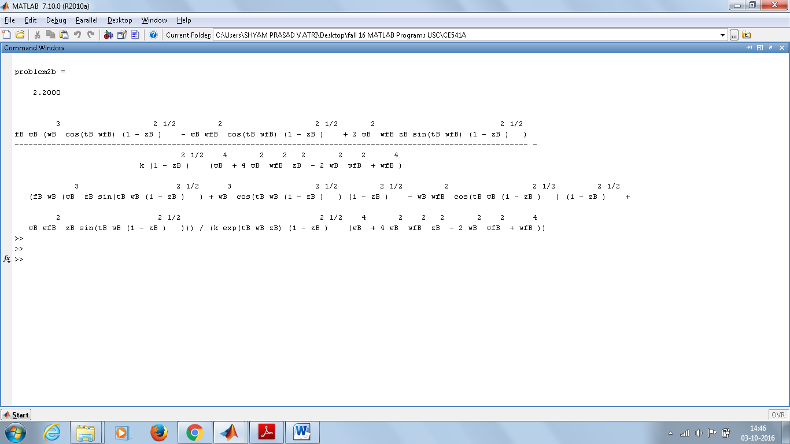

Plots

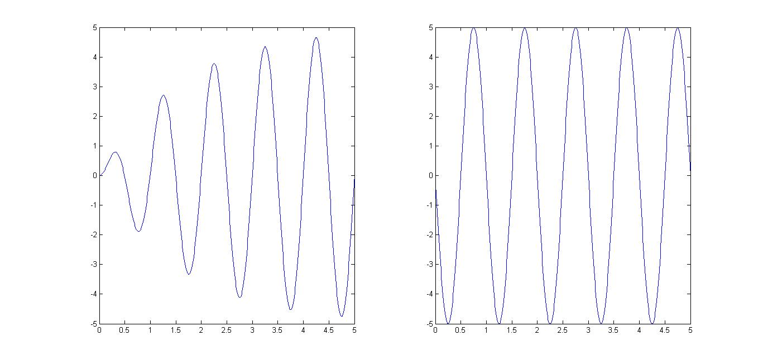

For Plot on LHS:- Plot using Duhamel integral.

For Plot on RHS:- Plot using solution derived in class.

We observe that the transient part dies out as the system reaches steady state.

Problem 2.3

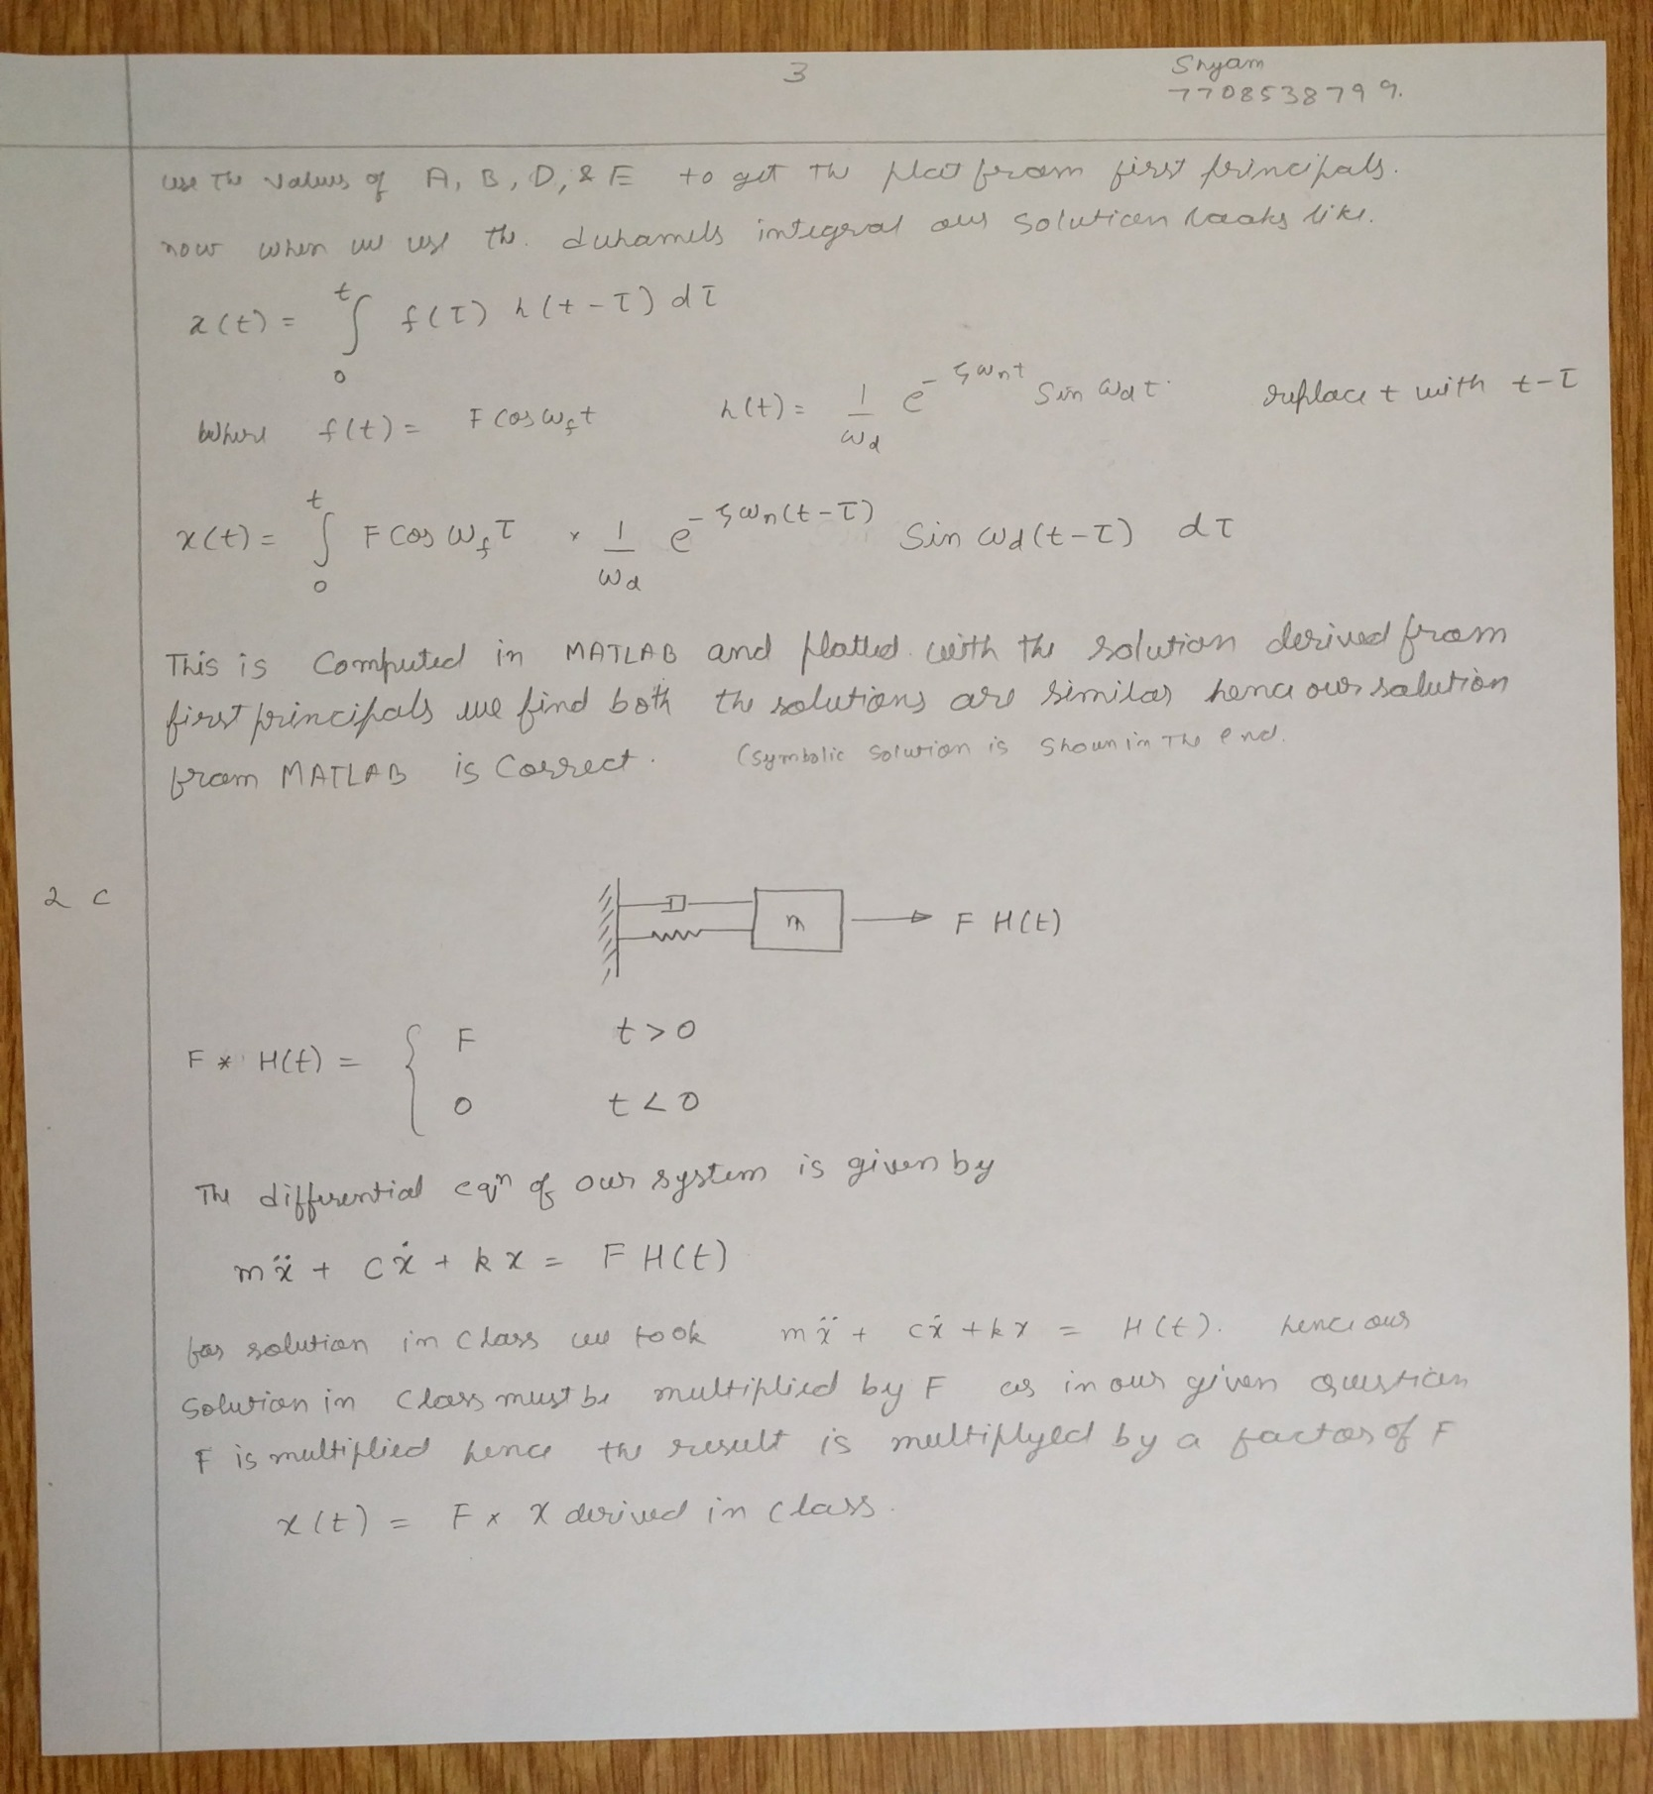

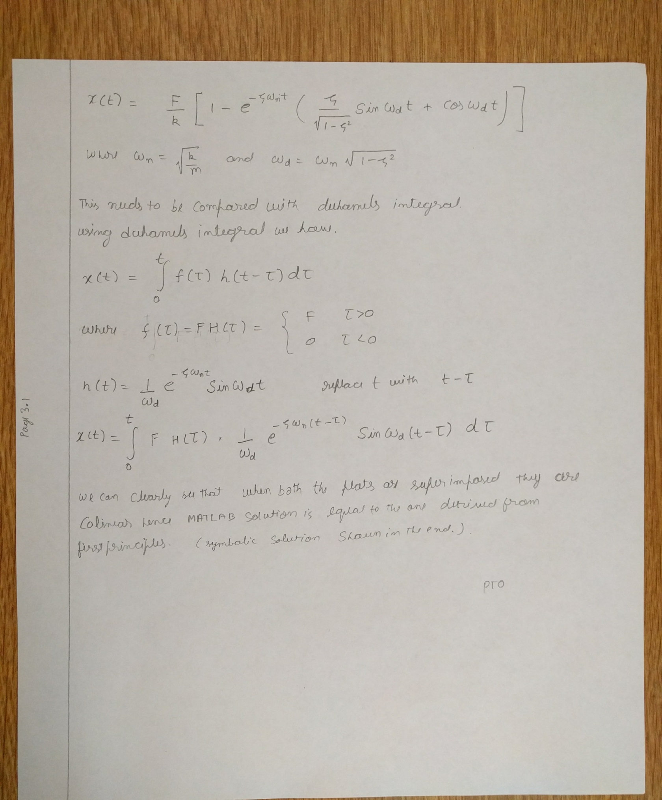

Symbolic Solution

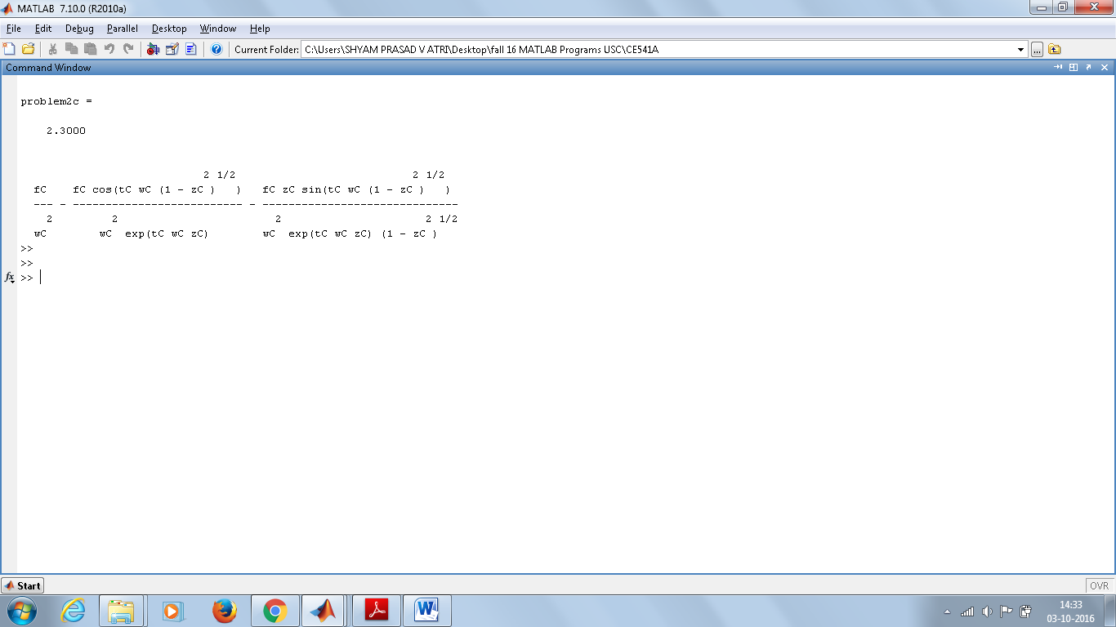

Super imposed plot of Duhamel integral and solution from class

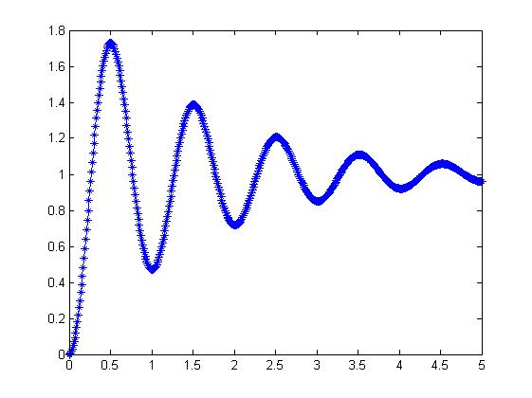

Individual plots

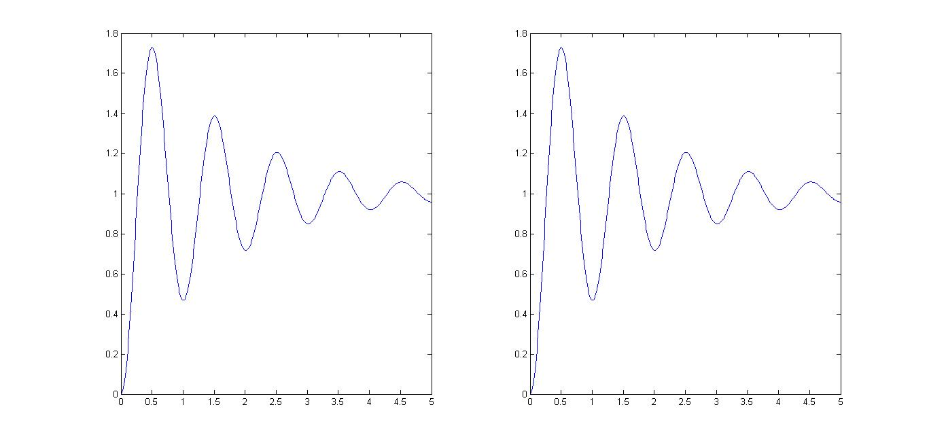

Problem 2d

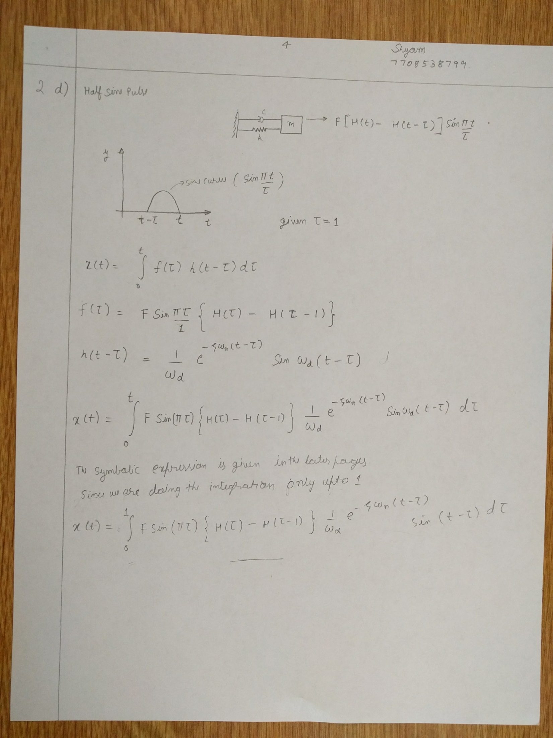

Symbolic Solution

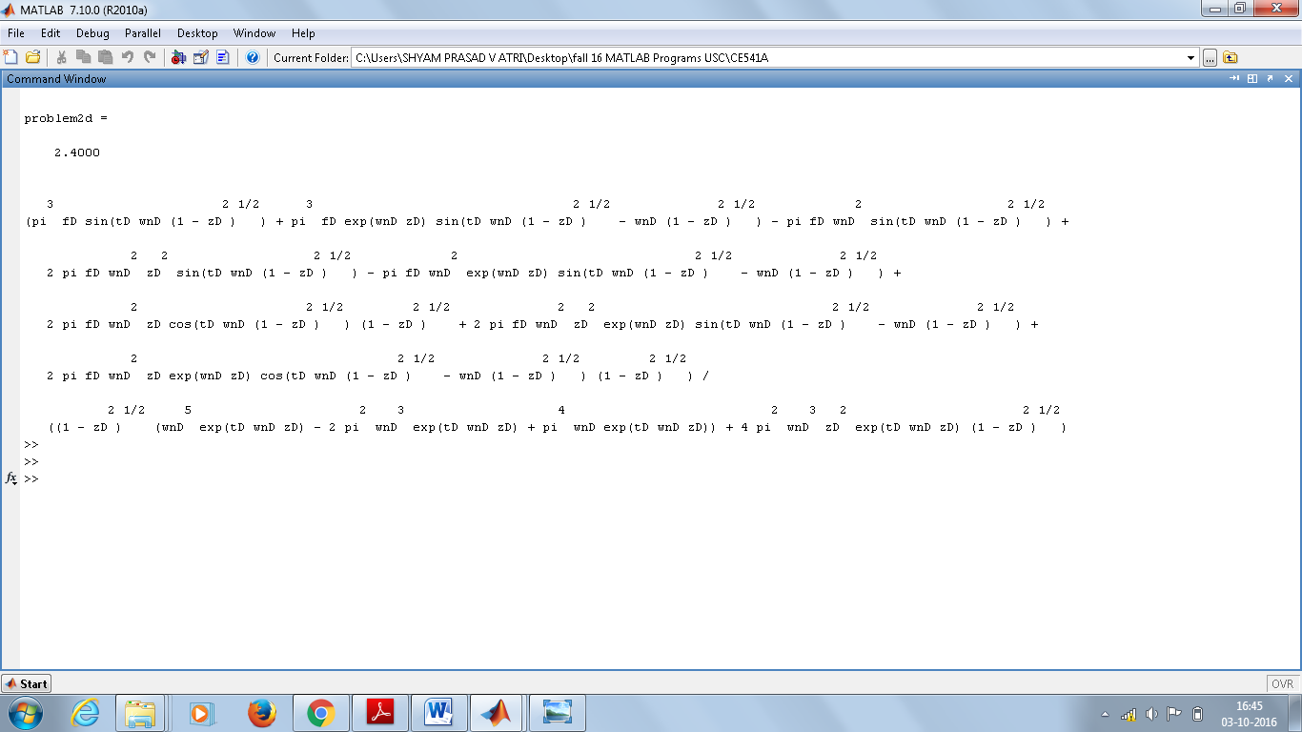

Plot

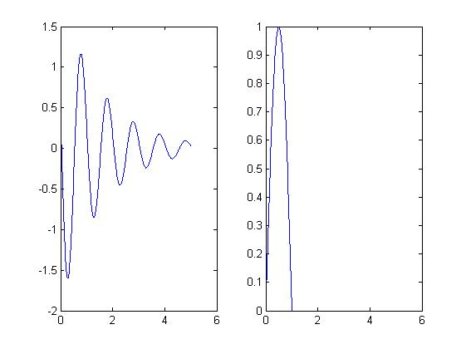

For Plot on LHS:- Plot using Duhamel integral.

For Plot on RHS:- half sine wave

Plot of all excitation functions

Image to LHS for problem 2a

Image to LHS for problem 2b

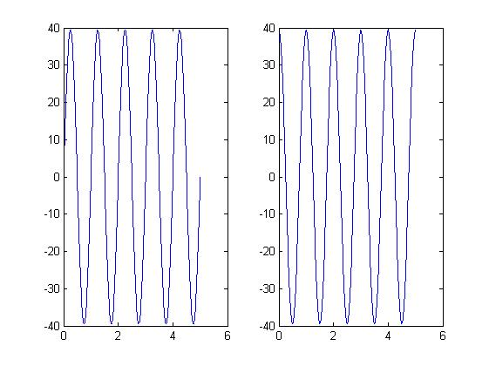

Excitation plot problem 2c

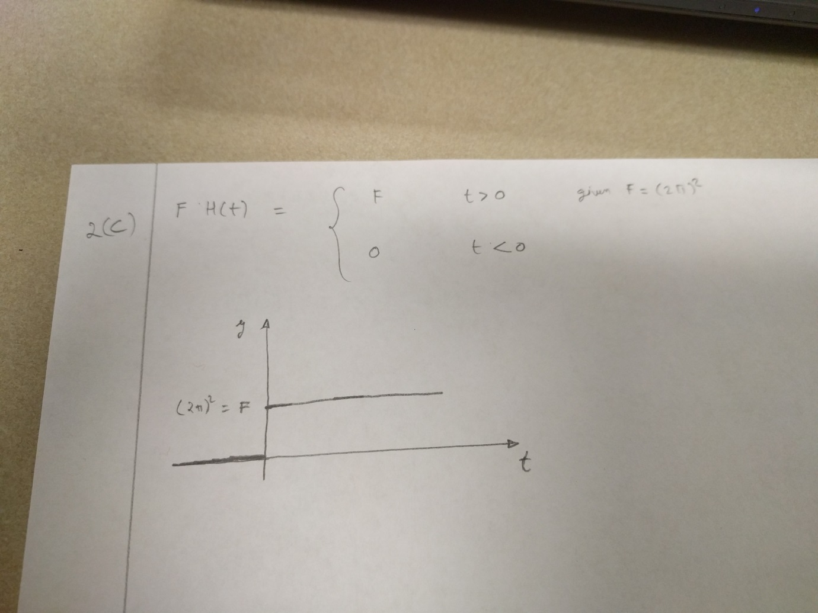

All Codes

clear all

clc

%----------------------------------------------

problem1=1

syms f1 wf1 t1 wn1 tau1 k1

v1=int((f1\*sin(wf1\*tau1)\*(wn1/k1)\*sin(wn1\*(t1-tau1))),tau1,0,t1);

simplify(v1);

pretty(v1)

%

clear all

clc

%------------------------------------------------------------

problem2a=2.1

syms fA wfA tA wA zA tauA k

vA=int((fA\*sin(wfA\*tauA)\*(wA/(k\*(1-zA^2)^0.5))\*(exp(-zA\*wA\*(tA-tauA)))\*(sin(wA\*(tA-tauA)\*(1-zA^2)^0.5))),tauA,0,tA);

k=4\*3.14\*3.14;

fA=4\*3.14\*3.14;

wA=2\*3.14;

zA=0.1;

wfA=2\*3.14;

tA=0:0.01:5;

res=eval(vA);

res;

t=0:0.01:5;

figure

subplot(1,2,1)

plot(t,res)

simplify(vA);

pretty(vA)

f=4\*pi\*pi;

omg=2\*pi; %omg -- wA

z=0.1; %z -- zA

omd=omg\*(1-z^2)^0.5;

omf=2\*pi; % omf-- wfA

mag=omf/omg;

t=0:0.01:5;

y=ones(1,size(t,2));

c=ones(1,size(t,2));

d=ones(1,size(t,2));

for i=1:size(t,2)

c(i)=(f/k)\*((1-mag^2)/((1-mag^2)^2+(2\*z\*mag)^2));

d(i)=(f/k)\*((-2\*z\*mag)/((1-mag^2)^2+(2\*z\*mag)^2));

y(i)=(c(i)\*sin(omf\*t(i))+d(i)\*cos(omf\*t(i)));

end

subplot(1,2,2)

plot(t,y)

clear all

clc

%----------------------------------------------

problem2b=2.2

syms fB wfB tB wB zB tauB k

vB=int((fB\*cos(wfB\*tauB)\*(wB/(k\*(1-zB^2)^0.5))\*(exp(-zB\*wB\*(tB-tauB)))\*(sin(wB\*(tB-tauB)\*(1-zB^2)^0.5))),tauB,0,tB);

k=4\*pi\*pi;

fB=4\*pi\*pi;

wB=2\*pi;

zB=0.1;

wfB=2\*pi;

tB=0:0.01:5;

res=eval(vB);

res;

t=0:0.01:5;

figure

subplot(1,2,1)

plot(t,res)

simplify(vB);

pretty(vB)

%

%

%

f=4\*3.14\*3.14;

omg=2\*pi; %omg -- wA

z=0.1; %z -- zA

omd=omg\*(1-z^2)^0.5;

omf=2\*pi; % omf-- wfA

mag=omf/omg;

t=0:0.01:5;

y=ones(1,size(t,2));

c=ones(1,size(t,2));

d=ones(1,size(t,2));

for i=1:size(t,2)

d(i)=(f/k)\*((1-mag^2)/((1-mag^2)^2+(2\*z\*mag)^2));

c(i)=(f/k)\*((-2\*z\*mag)/((1-mag^2)^2+(2\*z\*mag)^2));

y(i)=(c(i)\*sin(omf\*t(i))+d(i)\*cos(omf\*t(i)));

end

subplot(1,2,2)

plot(t,y)

clear all

clc

%-----------------------------------------------

problem2c=2.3

syms fC tC wC zC tauC k

vC=int((fC\*(1/(wC\*(1-zC^2)^0.5))\*(exp(-zC\*wC\*(tC-tauC)))\*(sin(wC\*(tC-tauC)\*(1-zC^2)^0.5))),tauC,0,tC);

k=4\*pi^2;

fC=4\*pi\*pi;

wC=2\*pi;

zC=0.1;

tC=0:0.01:5;

res=eval(vC);

% to get individual plot please uncomment this

figure

subplot(1,2,1)

plot(tC,res)

%hold on % when you want individual subplot please comment out this

simplify(vC);

pretty(vC)

f=4\*pi\*pi;

omg=2\*pi;

z=0.1;

omd=omg\*(1-z^2)^0.5;

t=0:0.01:5;

y=ones(1,size(t,2));

for i=1:size(t,2)

y(i)=(f/k)\*(1-exp(-z\*omg\*t(i))\*(sin(omd\*t(i))\*((z)/(1-z^2)^0.5)+cos(omd\*t(i))));

%y(i)=(1-exp(-z\*omg\*t(i))\*(sin(omd\*t(i))\*((z)/(1-z^2)^0.5)+cos(omd\*t(i))));

end

% to get individual plot please uncomment this

subplot(1,2,2)

plot(t,y)

%plot(t,y, '\*') % when you want individual subplot please comment out this

clear all

clc

%---------------------------------------------------

problem2d=2.4

syms fD tD wnD zD tauD

%we set the limit as 5 as we are doing it for half sine wave and we need

%only 5 amplitudes

vD=int((fD\*(heaviside(tauD)-heaviside(tauD-1))\*(sin(pi\*tauD))\*(1/(wnD\*(1-zD^2)^0.5))\*(exp(-zD\*wnD\*(tD-tauD)))\*(sin(wnD\*(tD-tauD)\*(1-zD^2)^0.5))),tauD,0,5);

%original expression

%vD=int((fD\*(heaviside(tauD)-heaviside(tauD-1))\*(sin(pi\*tauD))\*(1/(wD\*(1-zD^2)^0.5))\*(exp(-zD\*wD\*(tD-tauD)))\*(sin(wD\*(tD-tauD)\*(1-zD^2)^0.5))),tauD,0,tD);

%original expression

k=4\*pi\*pi;

fD=4\*pi\*pi;

wnD=2\*pi;

zD=0.1;

%wfD=2\*3.14;

tD=0:0.01:5;

%tD=0.5;

res=eval(vD);

t=0:0.01:5;

figure

subplot(1,2,1)

plot(t,res)

simplify(vD);

pretty(vD)

p=0:0.01:5;

qw=ones(1,size(p,2));

for i=1:size(p,2)

qw(i)=(heaviside(p(i))-heaviside(p(i)-1))\*(sin(pi\*p(i)));

end

subplot(1,2,2)

plot(p,qw)

%plotting all excitation functions

clear all

clc

t=0:0.01:5;

f=4\*pi\*pi;

p2a=ones(1,size(f,2));

p2b=ones(1,size(f,2));

for i=1:size(t,2)

p2a(i)=f\*sin(2\*pi\*t(i));

p2b(i)=f\*cos(2\*pi\*t(i));

end

figure

subplot(1,2,1)

plot(t,p2a)

subplot(1,2,2)

plot(t,p2b)